Exercise 5 -- RegARIMA Diagnostics

The file .\data\retail\Furniture and home furnishings stores.dat lists retail sales from these stores.

Import .\data\retail\Furniture and home furnishings stores.dat as a time series object and then create a seasonal object for the data called m1 using the default options. (By default, the program will choose a transformation, test for trading day and Easter, look for AO and LS outliers, and automatically choose an ARIMA model.) Include the arguments history.estimates = “fcst” and history.start=”2010.Jan” and x11 = “”.

Use the output file, the udg() function, or the view() facility to answer the following questions.

- What ARIMA model did the program choose? SARIMA(0 1 0)(0 1 1)

- Which regressors did the tests choose to include? Are they all significant?
Coefficients:
Estimate Std. Error z value Pr(>|z|)
Mon -0.0018685 0.0016372 -1.141 0.2538
Tue 0.0034166 0.0016038 2.130 0.0331 *
Wed 0.0025199 0.0015902 1.585 0.1130
Thu 0.0022434 0.0016030 1.400 0.1617
Fri 0.0090954 0.0016094 5.651 1.59e-08 ***
Sat 0.0017595 0.0016121 1.091 0.2751
Constant -0.0001400 0.0004536 -0.309 0.7575
AO2000.Dec -0.0623760 0.0123226 -5.062 4.15e-07 ***
MA-Seasonal-12 0.6384134 0.0484516 13.176 < 2e-16 ***

- What was the AICC? The average forecast error over the last three years?
The AICC = 3433.58, and the average forecast error over 3 years = 2.28%

- Were any lags of the ACF or PACF significant?
- R code: acf(residuals(m1))
Lags 2, 6, and 10 of the ACF and 2, 6, and 20 of the PACF. (Answers can also be found on output but they are more clear and easily found in the diagnostics and graphs.)
See graph below:
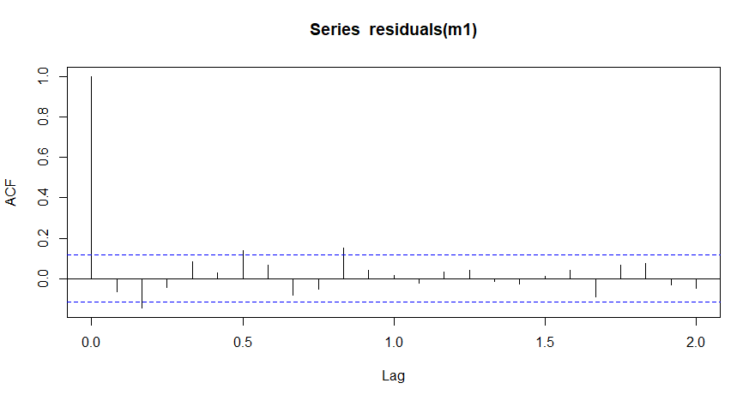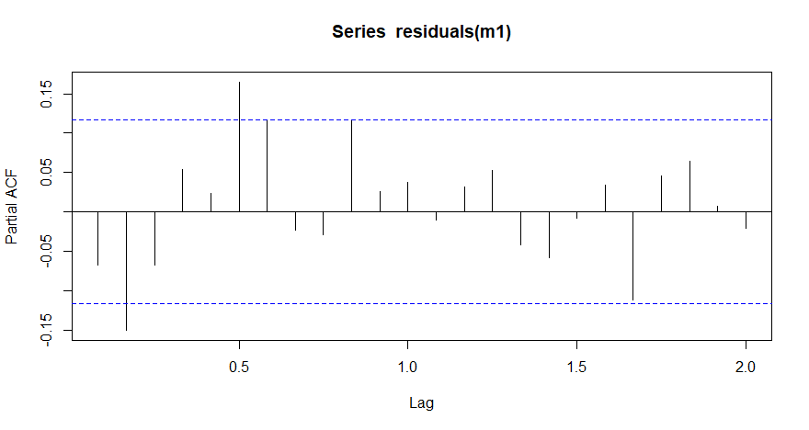

- At how many lags was the Ljung-Box Q significant?

15 lags

Create a second seasonal object for this series called m2 with:
- The regressors that were selected hard-coded (but remove any insignificant regressors)
- The transformation that was selected hard-coded
- The ARIMA model (0 1 2)(0 1 1)
- Outlier identification of AO and LS outliers
- The arguments history.estimates = “fcst” and history.start=”2010.Jan” and x11 = “ ”.

- Why might we think changing the model to (0 1 2)(0 1 1) would be good to try?
The ACF & PACF are both significant at lag 2, indicating some autocorrelation remaining in the residuals after they were fit with the model (0 1 0)(0 1 1). Therefore we might try an (0 1 2)(0 1 1) model to attempt to model that autocorrelation.

- Look at the ARIMA model parameters. Are they all significant?
Coefficients:
Estimate Std. Error z value Pr(>|z|)
AO2000.Dec -0.060608 0.012549 -4.830 1.37e-06 ***
Mon -0.001764 0.001670 -1.056 0.2908
Tue 0.003247 0.001628 1.995 0.0461 *
Wed 0.002786 0.001623 1.717 0.0860 .
Thu 0.002117 0.001631 1.298 0.1944
Fri 0.009040 0.001639 5.516 3.48e-08 ***
Sat 0.002025 0.001644 1.232 0.2180
MA-Nonseasonal-01 0.082527 0.059744 1.381 0.1672
MA-Nonseasonal-02 0.128571 0.060375 2.130 0.0332 *
MA-Seasonal-12 0.616887 0.049793 12.389 < 2e-16 ***

The MA parameter at lag 1 – θ₁ – is 0.08, which is between one and two standard errors of zero. This isn’t significant in the traditional statistical sense – greater than two standard errors from zero – but it is large enough that we wouldn’t want to skip it in a skipped lag model.

- Were any new outliers found? No

Is it valid to use AICC to compare these two models? If yes, then which model is preferred? Yes; they have the same model span, outliers, and order of differencing.
The AICC is smaller for the (0 1 2)(0 1 1) model, by almost 5.

- Is it valid to use the average forecast error over the last three years to compare these two models? If yes, which model is preferred?
It is always valid to use this for model comparisons.
The (0 1 2)(0 1 1) model results in slightly smaller forecast errors.

- Were any lags of the ACF or PACF significant?
Yes, at 6 and 10. These are not lags we worry about

- At how many lags was the Ljung-Box Q significant? 9 lags

Create an out-of-sample forecast error plot to compare the first and second models using the following commands:
h1 <- series(m1, "fce")
h2 <- series(m2, "fce")
diff1 <- h1[,1] - h2[,1]
diff12 <- h1[,2] - h2[,2]
sdiff1 <- (diff1 * length(diff1)) / h2[length(h2[,1]),1]
sdiff12 <- (diff12 * length(diff12)) / h2[length(h2[,2]),2]
plot(sdiff1,
ylim = range(sdiff1,sdiff12),
main = "Squared Forecast Error Differences, Model 1 – Model 3")
lines(sdiff12, col = "red")
abline(h=0, col = "grey")
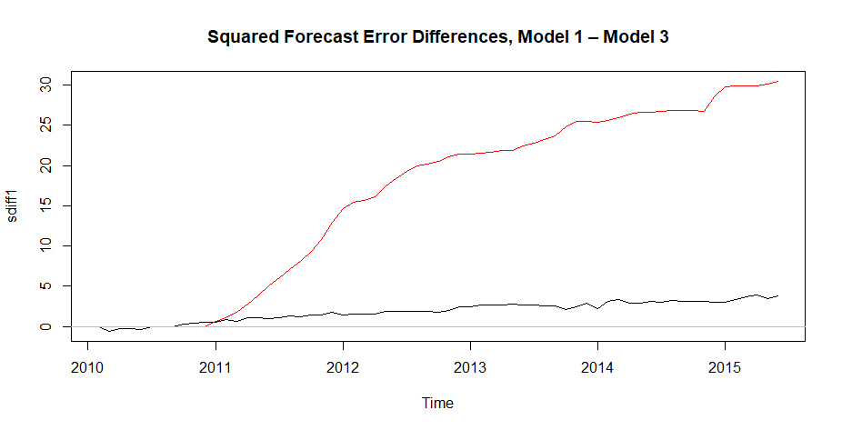

Does the graph prefer one model to the other?
At first glance, it looks like Lead 12 strongly prefers the second model, the one with the shorter model span (an increasing slope indicates consistently positive squared forecast error differences, so forecast errors are larger for Model 1). Lead 1 looks more inconclusive.

However, most of the Lead 12 preference for Model 2 was from 2011 to 2012.

Which of the three models do you prefer?
On the whole, diagnostics seem best for the second model.

